Adding a marker to the Deep Map app

**Step 1.** Go to the [Deep Map Database Webpage](http://www.djryan.ca/DeepMap/home.php)

**Step 2.** Select Add New

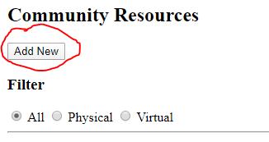

**Step 3.** Go to [Google Maps](https://www.google.ca/maps/)

**Step 4.** Click on the point you would like to add

**NOTE:** Do not click on an actual marker on Google Maps, click on an empty space instead

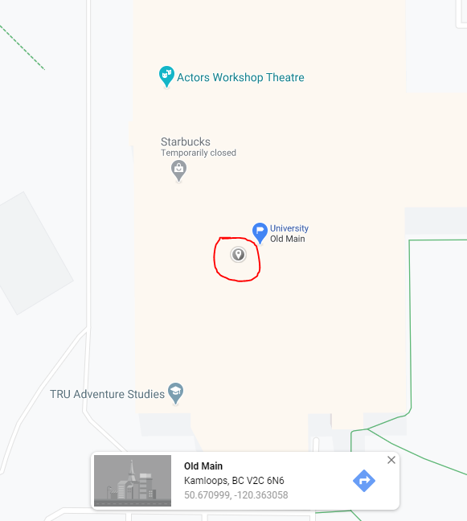

**Step 5.** Click on the **Coordinates**

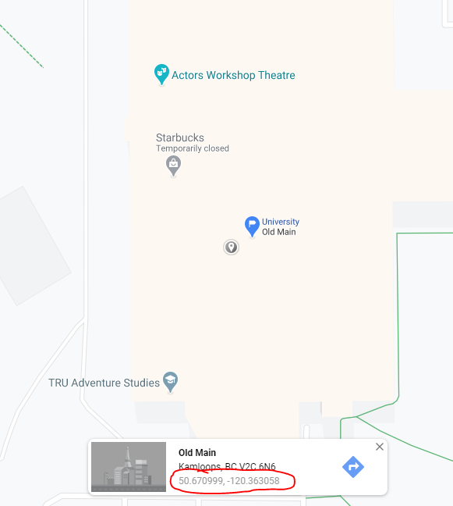

**Step 6.** Copy the Coordinates at the top of the screen

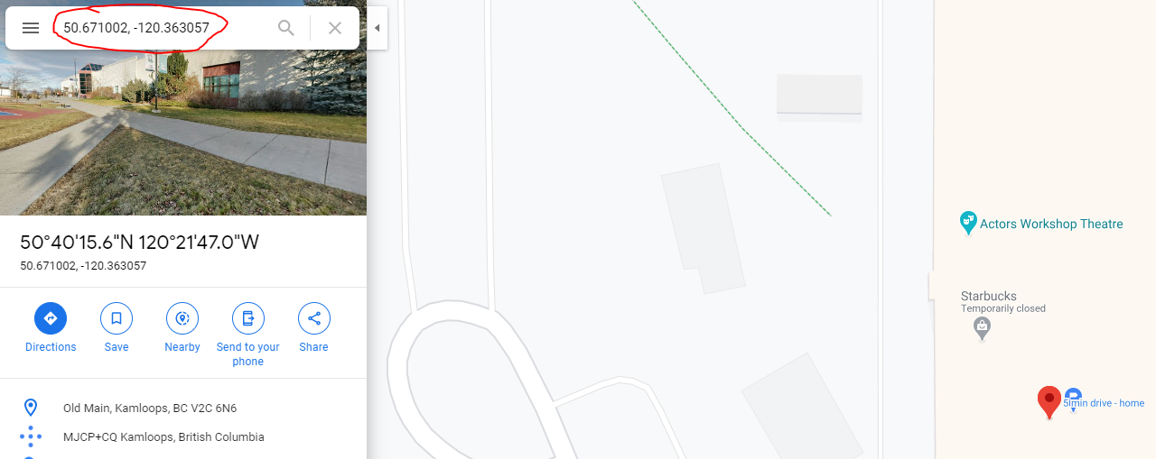

**Step 7.** Paste these coordinates into the Location field along with any other relevant information you’d like to add and click **Submit**

